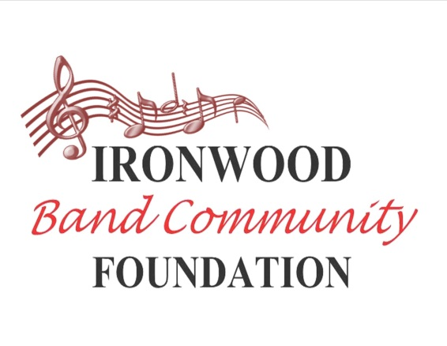
Community Information Form

The Ironwood Band Community Foundation (IBCF) is an independent, 501c3 non-profit that supports the Music Programs at Ironwood High School and area middle schools. Membership is open to the public. The IBCF informs, supports and represents all the families involved in the Ironwood Music Program regardless of their membership status.

If you would like to be kept informed of band and foundation activities, please provide your contact information. This information is for internal use only and will not be shared with anyone else.

Student Name (1): __________________________ Class of ______ Instrument ____________________
Student Name (2): __________________________ Class of ______ Instrument ____________________
Student Name (3): __________________________ Class of ______ Instrument ____________________
Parent: ______________________________________________ Phone: ___________________________

Parent: _____________________________________________ Phone: __________________________

Parent Email 1:_________________________________ Email 2: __________________________________

Mailing Address: __________________________________________________________________________

Please indicate your level of participation:

Information:
____ I am interested in receiving information about the band and its activities. (We currently send information via email, Remind [texting service], and our website.)

Volunteer:
____ I would like to volunteer. (Please indicate areas of interest on the list on the back of this sheet)

Ironwood Band Community Foundation: (Please see page 2 for more information)

_____ I would like to join the IBCF this year. My $10.00 dues ___ are attached ___ remind me later.

A second adult from your household or family can also join for an additional $5.00.

1st Adult: _____________________________________________ Cell Phone: ____________________

2nd Adult: _____________________________________________ Cell Phone: ____________________

You don’t have to be a member of the IBCF to volunteer or to receive information.

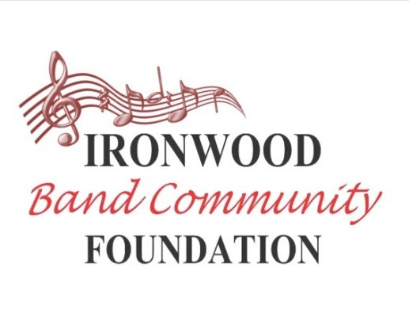

What does it mean to be a member of the IBCF?

The goal of the IBCF is to build a community of support around Ironwood and its local middle schools. We accomplish this through our efforts to strengthen and enrich our current programs at IHS as well as investing in the development of middle school musicians. Members can serve in leadership roles and assist in the design and implementation of Foundation goals. Members also have the opportunity to vote at meetings and help in setting the course of the IBCF for each school year. Anyone with a desire to help our kids is welcome. Membership dues are $10.00 a year.

The IBCF is staffed by volunteers, so we divide the tasks into twenty-seven (27) different roles to make the work manageable (see organizational chart). Most jobs can be done in an hour a week or less. There are also six Executive Team Members, also volunteers, who give additional time to the program.

You don’t have to be a member of the IBCF to volunteer or to receive information.

Please look over the following list, and check any of the tasks that you would like to learn more about or might be interested in serving:

___ writing/newsletters
___ web design
___ photography
___ videos
___ Facebook / Twitter etc.
___ communications
___ take notes
___ work with finances
___ reach out to alumni
___ sewing
___ donate snacks
___ network with donors
___ work with businesses
___ move equipment
___ carpentry
___ reach out to schools
___ serve in a leadership role
___ fundraising
___ help with carwashes
___ help with silent auction
___ event greeter
___ solicit donations
___ T-shirts/spirit gear
___ help with special events
___ sell spirit gear at games
___ other (fill in the blank)
_________________________________

Please check any of the below areas in which you have experience:

__ Media
__ Publicity
__ Sales
__ Business
__ Music
__ Military
__ Fundraising
__ Leadership

If there is anything else you would like us to know about yourself, please write it here:

Whatever your level of participation, thank you for your interest in the Ironwood Music Program and the Ironwood Band Community Foundation!

Please see the IBCF website for the most current information on the band: www.IronwoodBand.org
You can like us on Facebook to at: “Ironwood High School Band Fans”

Sign up for Remind: http://remind.com/join/mrsmarbo

